

August 10, 2024
Hunter Street Baptist Church

Back to the Basics: The Essentials

7:45 Registration
8:30 Welcome (Adult Choir Room)
8:50 Large Group – Susan Eernisse
9:50 Break
10:00 Large Group – Keith Pate
11:00 Large Group – Keith Watson
12:00 Lunch (Children’s Atrium)
12:35 Large Group – Terry Taylor
1:20 Break – Choose your Small Group Session
1:30 Small Group Sessions (See folder for details)
Susan Eernisse (preschool) - room S105
Keith Pate (younger) - room S107-108
Keith Watson (older) - room S112-114
Carrie DeLong (all ages) - room S101
Terry Taylor (all ages) - room S111

2:45 Large Group Closing and Grand Prize Drawing
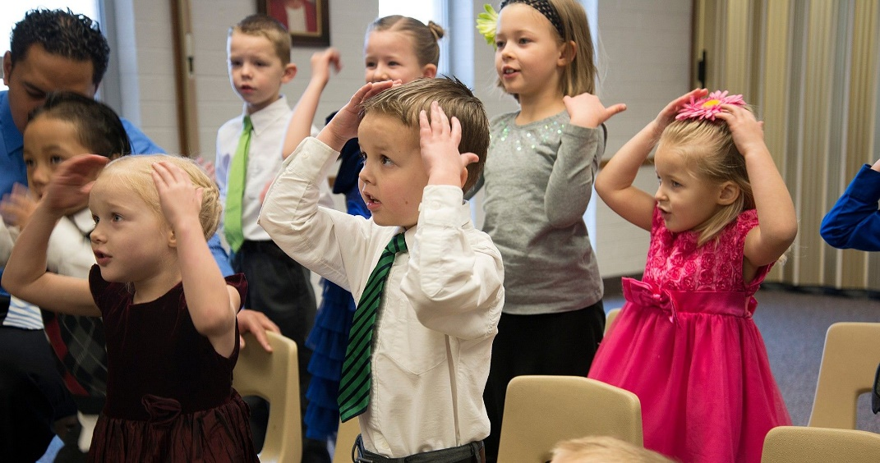
3:00 Dismiss

