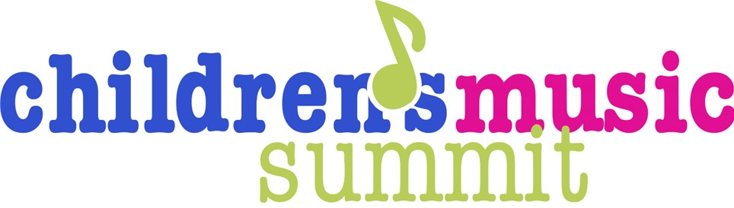

August 9, 2025
First Baptist Church, Pelham

YES!!
Melanee Horton (preschool) – Room 115
Sandy Stephenson (younger) – Room 114
Pam Andrews (older) – Fellowship Hall
Elizabeth Laube (all ages) – Room 116
Susan Eernisse (all ages) – Room 117

7:45 Registration – Coffee available
8:15 Welcome (Fellowship Hall)
8:45 Small Group 1 (See folder for details)
– Choose your breakout
9:45 Cookie Break
10:00 Small Group 2 (See folder for details)
– Choose your breakout!

11:05 Large Group (Fellowship Hall) – Pam Andrews
“YES! We Can Make Music Education Fun!”

12:05 Lunch (Fellowship Hall)
12:45 Large Group – Susan Eernisse
Jubilate Music Group

1:05 Large Group (Fellowship Hall) – Elizabeth Laube (Growing in Grace)
“God Rejoices Over Them”

2:05 Head to the next small group and grab a water or coffee!
2:20 Small Group Session 3 (See folder for details)
– Choose your breakout!
3:20 Large Group Closing (Fellowship Hall) and Grand Prize Drawing
3:30 Dismiss

